Final-Final lose ends to complete before soft launch! 6/10/17, 9:47 pm
Ok, last few things I found we should fix before soft launch..
Screenshot #1: Link need to change from old one to IMMBOL – under Both BUY and RENT
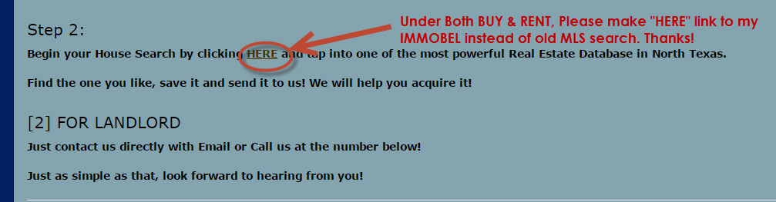
Screenshot #2: NO Link to “Contact Us” – under Both SELL tab
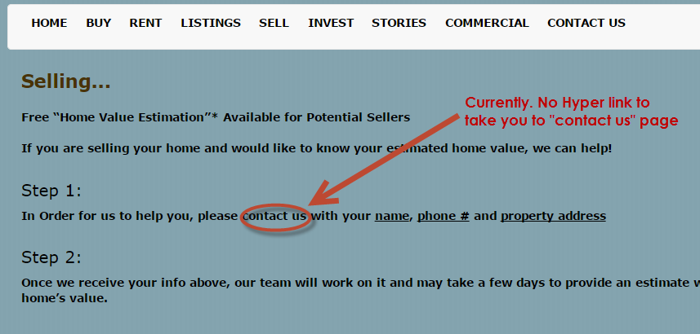
Screenshot #3: Please move signature to the right hand side – under “Contact Us” tab
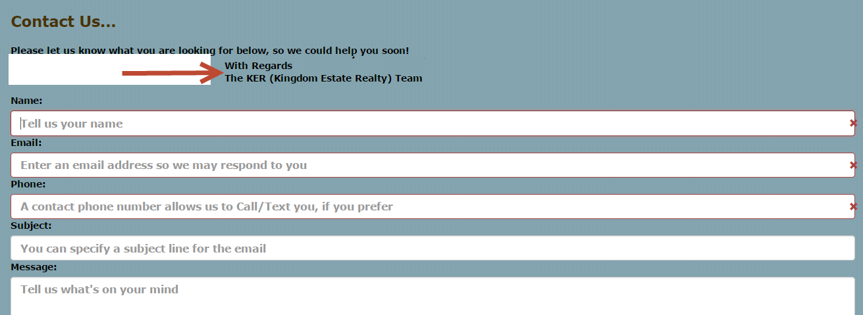
I think that is all I could find for QA purpose.. until next time..
Will talk more about cut over soon.. very soon.. Thanks man!

